Lambdas:

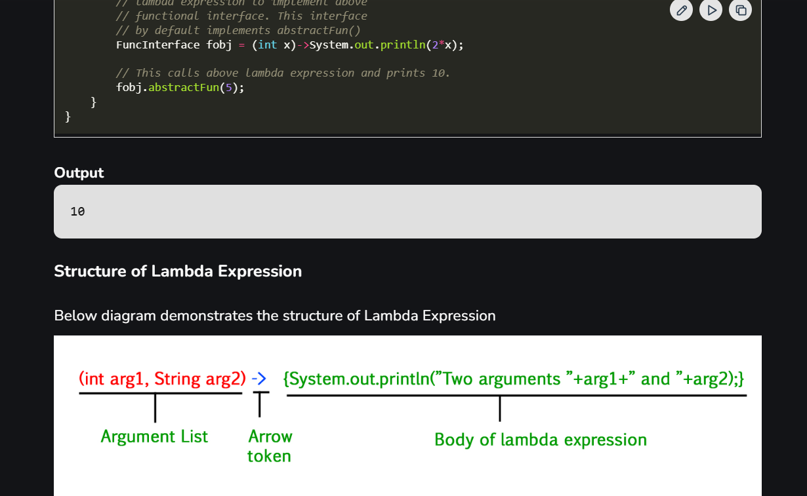

- Java Lambda Expressions
Lambda expressions in Java, introduced in Java SE 8, represent instances of functional interfaces (interfaces with a single abstract method). They provide a concise way to express instances of single-method interfaces using a block of code.
Functionalities of Lambda Expression
Lambda Expressions implement the only abstract function and therefore implement functional interfaces lambda expressions are added in Java 8 and provide the below functionalities.
- Functional Interfaces: A functional interface is an interface that contains only one abstract method.
- Code as Data: Treat functionality as a method argument.
- Class Independence: Create functions without defining a class.
- Pass and Execute: Pass lambda expressions as objects and execute on demand.
Example: Here, the below Java program demonstrates how lambda expression can be used to implement a user-defined functional interface.
// Java program to demonstrate lambda expressions
// to implement a user defined functional interface.

// A sample functional interface (An interface with
// single abstract method
interface FuncInterface
{
// An abstract function
void abstractFun(int x);

// A non-abstract (or default) function
default void normalFun()
{
System.out.println("Hello");
}
}

class Test
{
public static void main(String args[])
{
// lambda expression to implement above
// functional interface. This interface
// by default implements abstractFun()
FuncInterface fobj = (int x)->System.out.println(2*x);

// This calls above lambda expression and prints 10.
fobj.abstractFun(5);
}
}
Output
10
Structure of Lambda Expression
Below diagram demonstrates the structure of Lambda Expression
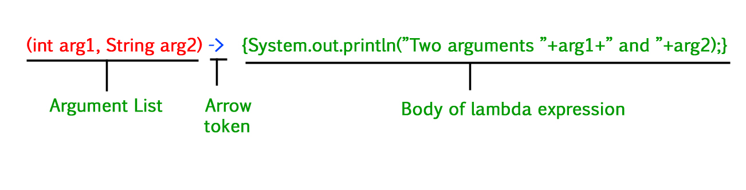Syntax
Java Lambda Expression has the following syntax:
(argument list) -> { body of the expression }
Components:
- Argument List: Parameters for the lambda expression
- Arrow Token (->): Separates the parameter list and the body
- Body: Logic to be executed.
Lambda Expression Parameters
There are three Lambda Expression Parameters are mentioned below:
- Zero Parameter
- Single Parameter
- Multiple Parameters
// A Java program to demonstrate simple lambda expressions

import java.util.ArrayList;
class Test {
public static void main(String args[])
{
// Creating an ArrayList with elements
// {1, 2, 3, 4}
ArrayList<Integer> arrL = new ArrayList<Integer>();
arrL.add(1);
arrL.add(2);
arrL.add(3);
arrL.add(4);

// Using lambda expression to print all elements
// of arrL

System.out.println("Elements of the ArrayList : ");
arrL.forEach(n -> System.out.println(n));

// Using lambda expression to print even elements
// of arrL
System.out.println(
"Even elements of the ArrayList : ");
arrL.forEach(n -> {
if (n % 2 == 0)
System.out.println(n);
});
}
}

Multiple parameters:
@FunctionalInterface
interface Functional {
int operation(int a, int b);
}

public class Test {

public static void main(String[] args) {
// Using lambda expressions to define the operations
Functional add = (a, b) -> a + b;
Functional multiply = (a, b) -> a * b;

// Using the operations
System.out.println(add.operation(6, 3)); // Output: 9
System.out.println(multiply.operation(4, 5)); // Output: 20
}
}

